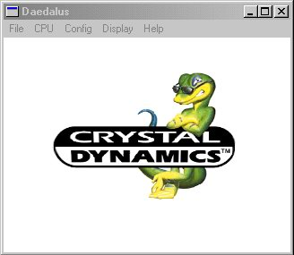
Multi platform emulator that became more well know when it's graphics code became a plugin! If you liked the plugin try the real thing and cross your fingers.

